Functional Requirements

1. Students

Home > Login / Signup > User dashboard

**Profile:**

It should contain the details of user such as user name, USN, branch, section, event name, phone number, year and email id.

**Calendar of events:**

There should be many clubs such as palette (drawing), razzle (dance), chords (music), captcha (photography and videography), pixel (editing), mask (drama), speakers and LLR (speakers league).

Select the event:

Description: The user can select the event and also select payment method.

Input: Main event, Sub event, Enrolment number, Add team member.

Output: Event selected Successfully, also see all detail and delete also.

Processing: The System will add selected data into database.

**Registration:**

Description: To enter into this site user has to register himself first. Requirements of registration are first name, last name, email-id, password, confirm password etc.

Input: User Details

Output: Filled Registration Details.

Processing: User details are checked with database. Password constraint is checked as per validation.

**Payment:**

Payment can be done through online or cash. After the payment the admin will provide the user with the receipt.

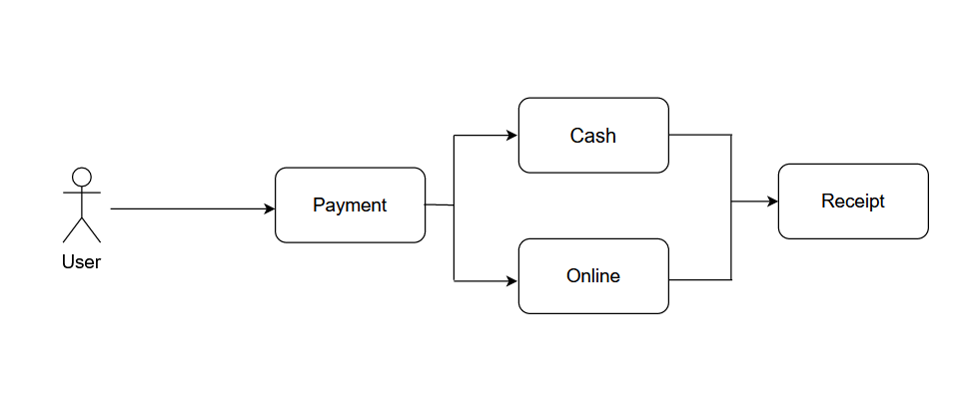

**Status of registered event:**

After the successful completion of registration, the admin comes to know the number of users joined the club.

2)Admin

**Admin panel**

Description: The Admin can add manager, main event, sub-event also.

Input: main event, sub-event, manager.

Output: Add successfully in database.

Processing: The system will add selected data into database.

**Manager panel**

Description: The manager can add volunteer, main event and sub-event also.

Input: Main event, sub-event, volunteer.

Output: Add successfully in database.

Processing: The system will add selected data into database.

**Logout**

Description: The system provides the facility to logout from the site

Input: Select logout option

Output: Logout from the system

Processing: User will logout

